Website overall comment:
- It is very white: Add color
- We would like the menus to be on different page
- Make the menu fixed
Home | About | Services - Logo - Gallery | Our Process| Contact : with a transparent background as an option or white background
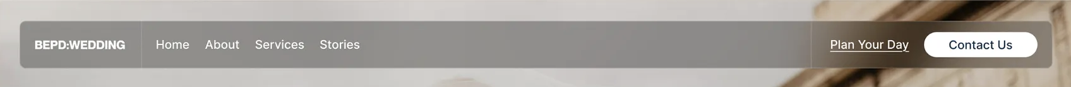

HOME
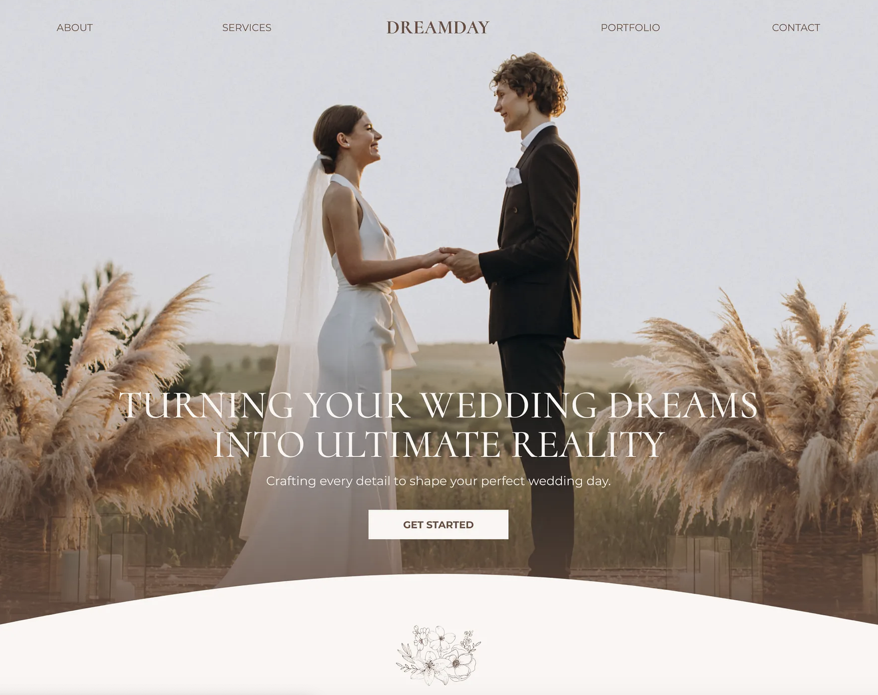

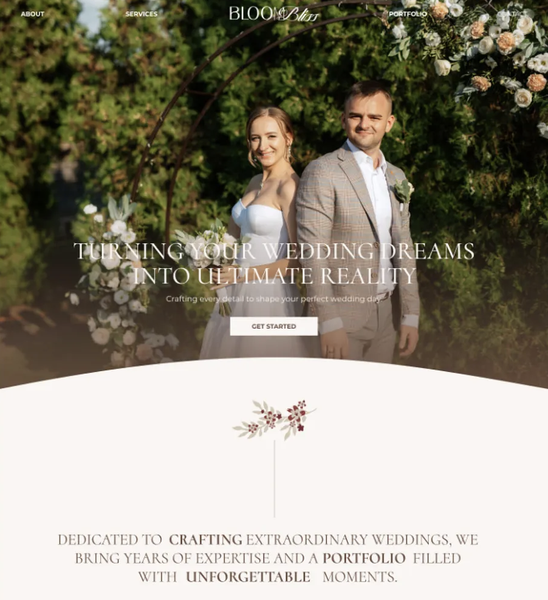
Hero slideshow Image
Overlay: Be a guest at your own event
Button: Get started
Flower that divides
Our passion lies in ensuring you feel cared for, confident, and free to enjoy every moment of your event.

Services Preview
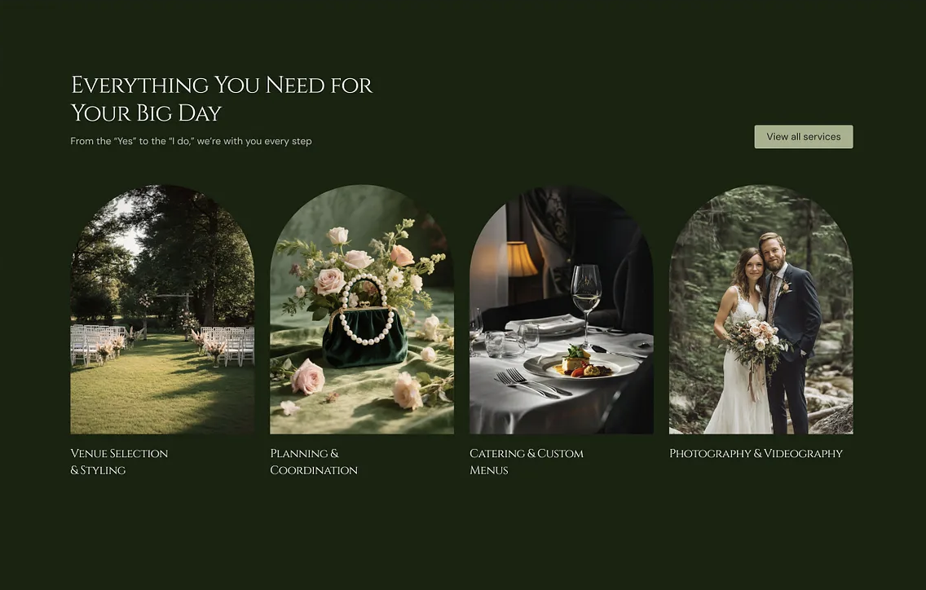
Explore our event planning services.
Button: View Services
- Wedding-Day Coordination
- Full Wedding Management
- Mels Day Planning
- Corporate Events

- Testimonials
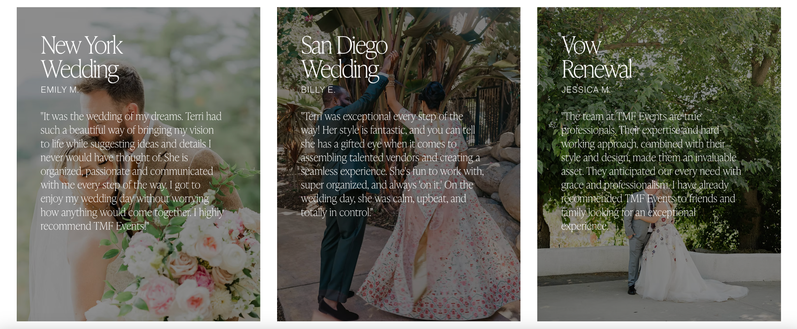

Bethlehem and Nahom
- Thank you so much for all your hard work, care, and attention to every detail. Everything came together so beautifully and smoothly, and we truly couldn’t have asked for a better team. Thank you for making our day so special and stress-free. We are incredibly grateful for each and every one of you. May God bless you all!
Faysel and Cece
- We are so thankful for everything you did for us for our wedding. You did such an excellent job and went above and beyond. We are so thankful for you guys!! It was such a special day and you made it great.
Rekik and Nahom
- I first found WEG through social media, and I had a vision of how I wanted my wedding day to feel: calm, stress-free, and relaxed. Weg made that vision a reality.Thank you so much for being there for us, supporting us, and taking care of everything. You made our day feel truly special, and we are so grateful for how stress-free and joyful the experience was.

- FAQ?

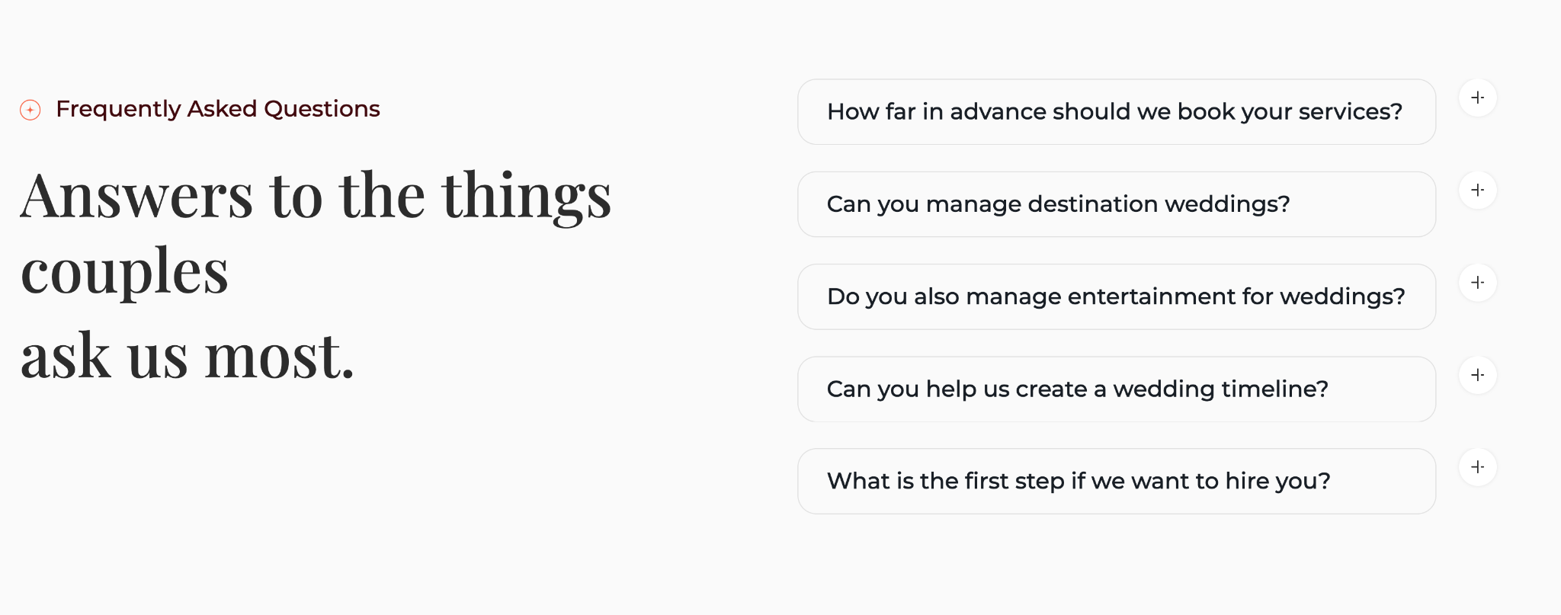
Frequently Asked Question
Start here for answers

How far in advance should we book your service?
- We recommend booking WEG as early as possible to ensure we can give your event the time, attention, and care it deserves. For weddings and larger events, we suggest reaching out at least 3–6 months in advance. However, we understand that every event is different, and we are happy to discuss availability for events with shorter timelines.
What types of events does WEG Events plan?
- WEG Events plans a variety of celebrations and gatherings, including weddings, corporate events, conferences, book launches, destination weddings, and special events.

What is the first step if we want to hire you?
- The first step is to get in touch with us and share your event details and needs. After reviewing our packages and deciding to move forward, we’ll schedule a meeting to learn more about your vision, ask important questions, and create a personalized plan.
How much do your event planning services cost?
- Our pricing depends on the package you choose and the specific services you need. Contact us to learn more about our packages and find the option that best fits your needs.
Do you help with choosing and managing vendors for weddings?
- Yes, our services depend on the package you choose. Our full planning package includes helping you select vendors that fit your needs and budget, as well as managing communication and coordination with them. For our day-of coordination package, we focus on managing the vendors and ensuring everything runs smoothly on the event day.

About
Hero Image

Overlay: About Us
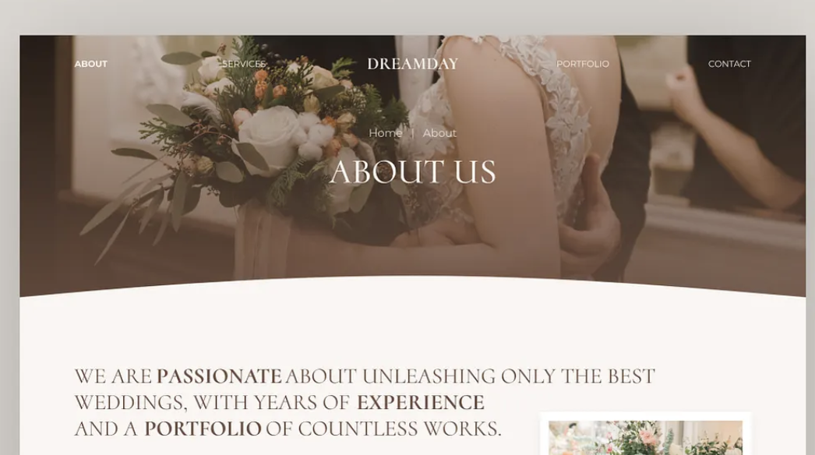
WEG was born from a love of celebration. We carried a passion for creating an event company and pursued that passion through learning and preparation. Bethel earned her degree in Event Management in Switzerland, and after returning, she shared that passion with Halaluya and Rakeb as we took the first steps toward building WEG Events.
The name WEG came from our desire to give it an Amharic name that reflects our culture. “Weg” means a traditional custom, and one of our traditions is coming together to celebrate.
Today, we continue building WEG Events into a company committed to bringing people together.

- Mission and vision?


- Mission: With Weg Events, you get to relax and simply be a guest at your own event.
- Vision: To set a new standard in event experiences through thoughtful planning, genuine care, and professionalism.

- Meet the Team

- Bethel Berhanu, Co founder and Lead Planner
- Haleluya Temesge, Co founder and Lead Planner
- Rakeb Yehwalashet, Co founder and Lead planner

Services
Hero Image

Overlay: Our Services
Have two photos but curve the bottom

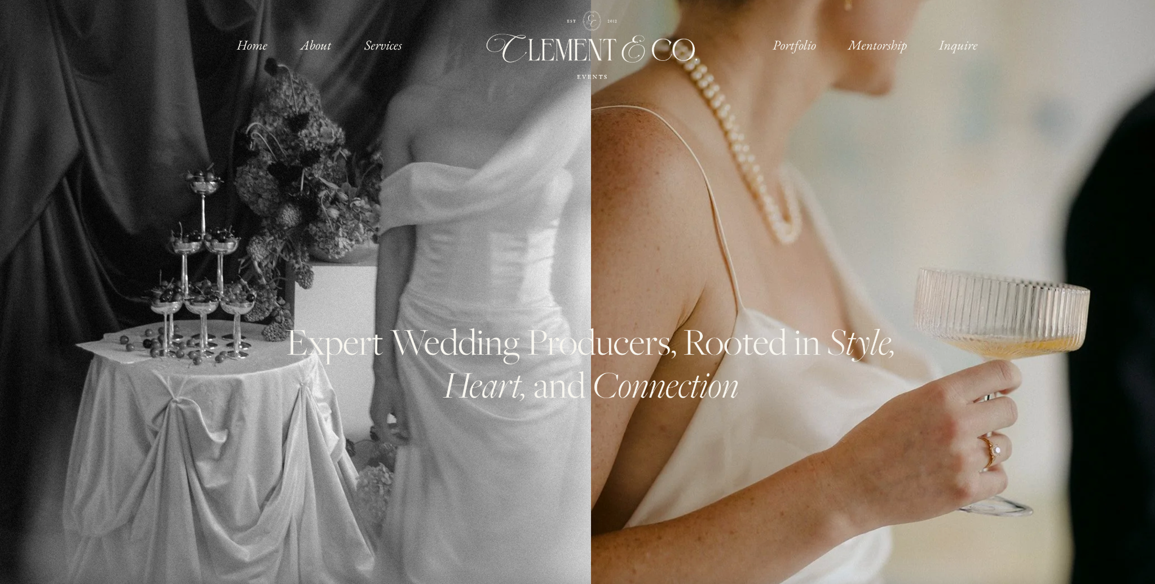

From weddings to corporate events, we provide planning and coordination services that bring organization, care, and professionalism to every event.
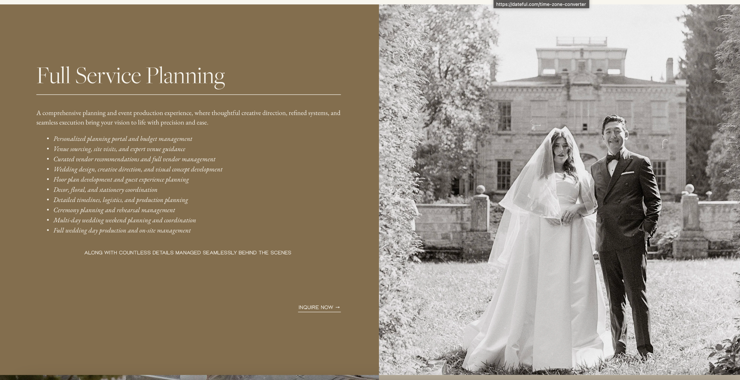
Note: switch the photo and text for the next one

- Wedding-day Coordination
- Pre-wedding guidance session
- Follow-up meeting two weeks before the wedding
- Detailed wedding day timeline creation
- Rehearsal planning and coordination
- Vendor communication and management
- Wedding day coordination and event flow management
- Vendor payment handling on the wedding day
- Protocol service (Optional extra service)
- Troubleshooting & Problem-Solving

- Full Wedding Management
Everything in wedding day coordination plus
- From wedding preparations to the last guest, we manage every detail.
- Initial meeting to talk about Vision, Preferences and Priorities
- Offer Creative advice on the style, look and feel of the wedding.
- Researching and presenting personalized vendor options
- Provide overall guidance on wedding planning and decision-making.
- Online Monthly Progress Meetings to review task completion and follow-up on details and sending reminders.
- Managing communication with all vendors and serving as the main point of contact between the couple and vendors.
- Mesk Day (Photoshoot Day) Management with on-site guidance, and two protocol assistants to ensure the day runs smoothly

- Mels Day Planning
- Creating a detailed timeline
- Vendor communication and management
- On-Site Coordination and event flow management
- Troubleshooting & Problem-Solving

- Corporate Events
- Conferences and summits
- Product launches
- Trainings and workshops
- Corporate Retreats
- Seminars
- Annual meetings
- Company celebration
- Other Corporate Events

Gallery
Hero Image

Overlay: Gallery
Note: Photos of 13 wedding and 1 book launch
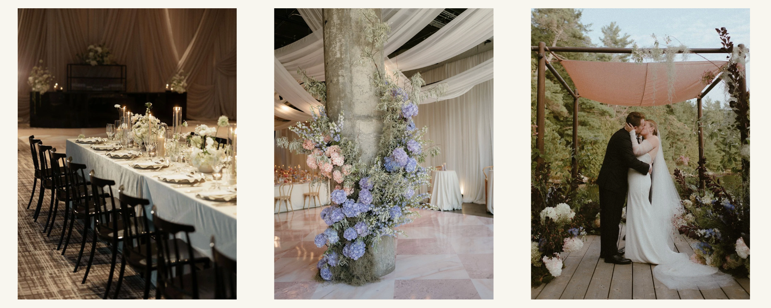
Couples name
Wedding Date

Our process
Hero Image
Overlay: Our Process
Keep as it is but with out movement and remove photos from the back and Use color here as well
Three simple steps to begin planning with Weg Events
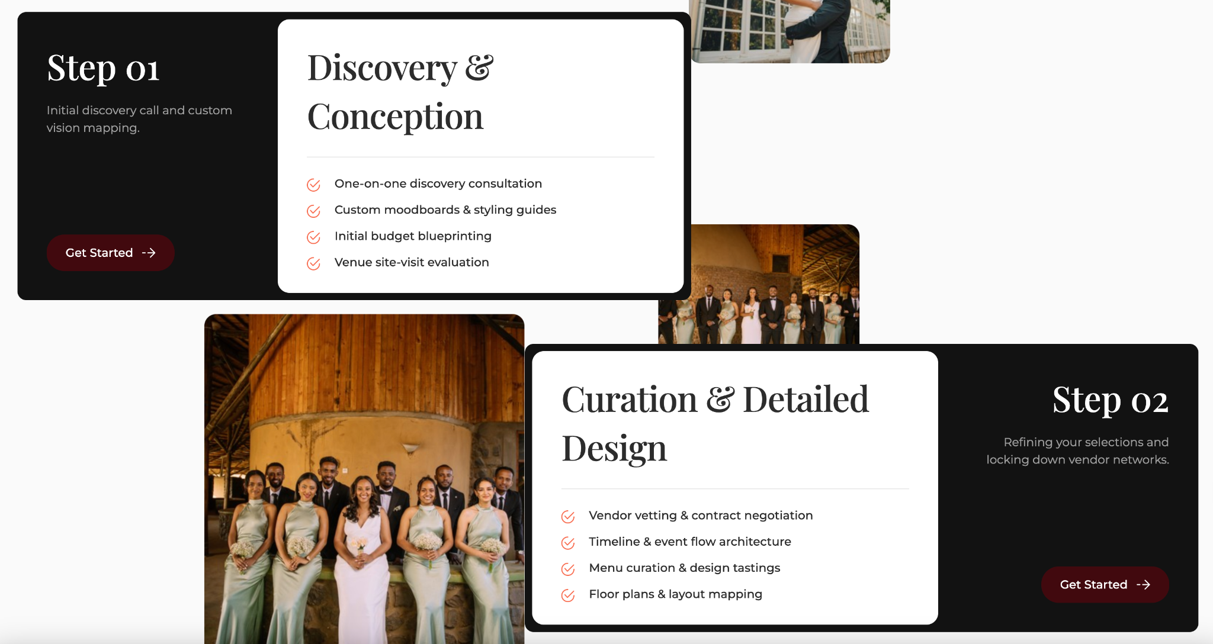

Step 01
Initial Inquiry
- Check your event date availability.
- Share your event details and requirements.
- Ask any initial questions.
- Button: Get started

Step 02
Review Our Packages
- Receive our service package
- Choose the package that best fits your needs.
- Button: Get started

Step 03
Booking
- Sign the service agreement in person
- Pay the required deposit to confirm your booking.
- Begin planning your event with the WEG team.
- Button: Get started

Link to Contact us page
- Have this on every page at the bottom before the footer


Contact:
Hero Image

Overlay: Your Celebration Begins here
Name, Phone, Email, Event Date, Approximate Guest count, service you are interested in: List our service, Message -> Submit
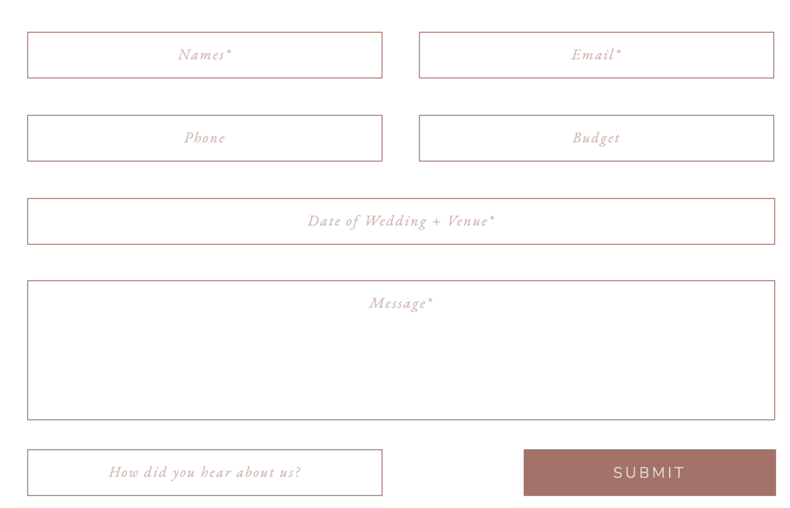
Email: info@wegevents.com
Phone: +251954920010

Footer
- Linkedin, Instagram, Tiktok
- Have the up arrow button that takes us back
- © 2025 Weg Events. All rights reserved.



Website Inspo Links
- https://dribbble.com/shots/25477830-Bloombliss-Wedding-Planner-Website-2025
- https://dribbble.com/shots/23346307-DreamDay-Wedding-Planner-Landing-Page-Figma-Template
- https://dribbble.com/shots/27215221-Wedora-Luxury-Wedding-Planner-Website-Design
- https://dribbble.com/shots/26670723-Wedding-Planner-Website-UI-Design-Exploratio
- https://www.clementandcoevents.com/
- https://rainbowchan.com/about

